**Final Project Proposal**

Name: LIU Yuchen

Student ID: 1155115211

**Background and problem statement**

As a mainland student studying in Hong Kong, it is not only the study that brings me whole new vision, but also the culture and landscapes that opened my perspectives. I’m also an outdoor person that loves adventure and nature so that hiking in Hong Kong is one thing that I can’t miss here.

However, I found it quite difficult to take my first step to get into wild. Firstly, being in a strange city, I have no knowledge about the hiking destinations and searching online takes lots of time because of the information are fragmented. Second, there’s no source for me to know about each hiking routes and how to plan my trip. Last but not least, forming a community and finding people share the same passion with is one of the most exciting parts of outdoor activities. But for people who are new here, it is also difficult to find hiking partners.

This inspired me to design a personal blog to share with travelers who love hiking and also express my own passion for outdoor activities in the final project.

**Target Audience and Objectives**

The target audience of this website are international students and mainland students in the Chinese University of Hong Kong.

For these groups of people, they have the interest to go hiking but not familiar with the routes and transportation. In addition, they would like to choose a destination with great views and take pictures along the way as well as get close to nature and take exercises. To dig into the emotional part of the website, for students that stay in Hong Kong for a short period of time, the exploration of the city and the curiosity drives them to eager more to

Therefor, the objective of this website is to provide information of the most popular hiking destinations and a blog where hiking lovers can find partners and organize activities online. The detailed structure will be explained below.

Competitor

There are some websites providing tourist information like discoverhongkong.com which is an official travel website of Hong Kong. It

**Structure and content**

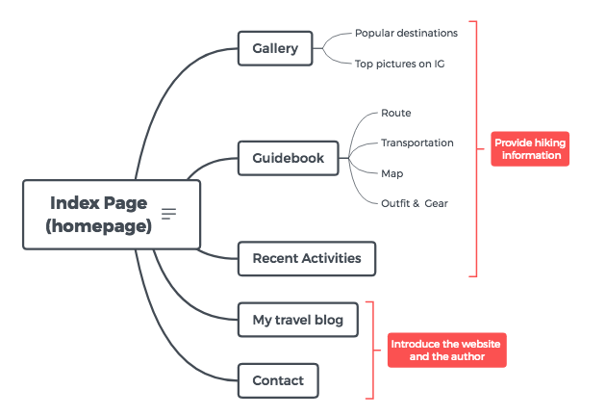

* **Index page:**Index page (Homepage of the website) will be a short introduction of what the website for and some multimedia elements created for the website (for example, logo and short video) to make it more aesthetically pleasing. There will have a navigation part section to lead users to explore other pages of the website.
* **Gallery:**This page will display some selected pictures of popular hiking destinations taken by other travelers to cater to the needs of visitors. Users can also make comparison in this page by using the like function to decide which place to go to.
* **Guidebook:**Information about all the destinations will be collected and showed in this page. A map will be adopted to show the location of these destinations. For unprofessional hikers, what to wear and prepare for hiking is always a big headache, so this page will provide some information about the hiking outfits and gear.
* **Recent Activities**This page serves as an e-board where visitors can check out the recent activities and sign up to join.
* **My travel blog and Contact:**

These two pages will include some travel diaries and information about myself to share my passion and encourage users to enjoy outdoor activities. The contact page also serves as an inquiry page.

**Monitoring and evaluation**

Use Google analytics as the tool to monitor and evaluate the website. As the objective of this website is to provide information and attract more user to use this information to check this website, the duration on the website and the number of pages visitors navigate to will be one of the conversion goals. Besides, as the ultimate goal is to encourage students who have the interest to go outdoors to organize activities and go hiking, the number of students who sign up for the hiking activity will also be counted as the conversion goal.

**Project Timeline**

|  |  |
| --- | --- |
| Task | Start and end date |
| Wireframes | 11.19-11.22 |
| Multimedia design and information collection | 11.19-11.25 |
| Development | 11.25-12.1 |
| Usability Test and optimization | 12.1 |
| Presentation | 12.3 |